

Enterprise Standards and Best Practices in IT infrastructure

4th Year, 2nd Semester, 2016

Assignment

**VMware vMotion**

Submitted to

Sri Lanka Institute of Information Technology

IT13095772

Dumendra W.A.S.

In partial fulfillment of the requirements for the

Bachelor of Science Special Honors Degree in Information Technology

**VMware vMotion**

Storage vMotion is a component of [VMware](http://searchvmware.techtarget.com/definition/VMware-VMFS) vSphere that allows the live migration of a running virtual machine's ([VM](http://searchservervirtualization.techtarget.com/definition/virtual-machine))  [file system](http://searchvmware.techtarget.com/definition/VMware-VMFS) from one storage system to another, with no downtime for the VM or service disruption for end users. This migration occurs while maintaining data [integrity](http://searchdatacenter.techtarget.com/definition/integrity).

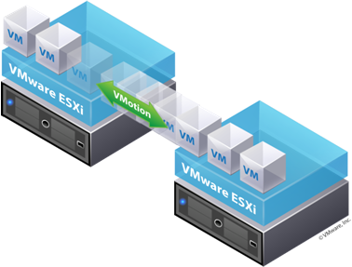

**Requirements and Prerequisites**

* The hosts must be licensed for vMotion (at least one vSphere Essentials Plus license on the corresponding ESXi host).
* At least one vMotion interface (minimum 1GB adapter)
* Same naming for virtual port groups.
* Same VLAN and VLAN label.
* Sufficient resources on the target hosts.
* All hosts should have access to the same data stores and networks.
* Virtual machine should be running on one of the supported operating systems.

**Hardware Requirements**

* CPU compatibility
* vMotion interface (minimum 1 Gb adapter)
* shared central mass storage
* same naming for virtual port groups
* sufficient resources on the target host
* at least one vSphere Essentials Plus license on the corresponding ESX host

**Advantages and Disadvantages in vMotion**

**Advantages**

* Zero downtime (no downtime)
* Continuous service availability
* Useful when performing maintenance on the ESXi host
* Maximum hardware utilization and availability.
* Load balancing

**Disadvantages**

* Does not allow migration with vMotion between Intel and AMD processors.
* BIOS settings of the hosts need to enable hardware virtualization and execute protection.